بسمه تعالی



پروژه طراحی پایگاه داده‌ها

دامنه‌های صفات

استاد

دکتر امینی

پارسا محمدیان ۹۸۱۰۲۲۸۴

سارا آذرنوش ۹۸۱۷۰۶۶۸

ارشان دلیلی 98105751

دامنه‌های صفات

در زیر جدول‌های پایگاه داده را مشاهده می‌کنید.

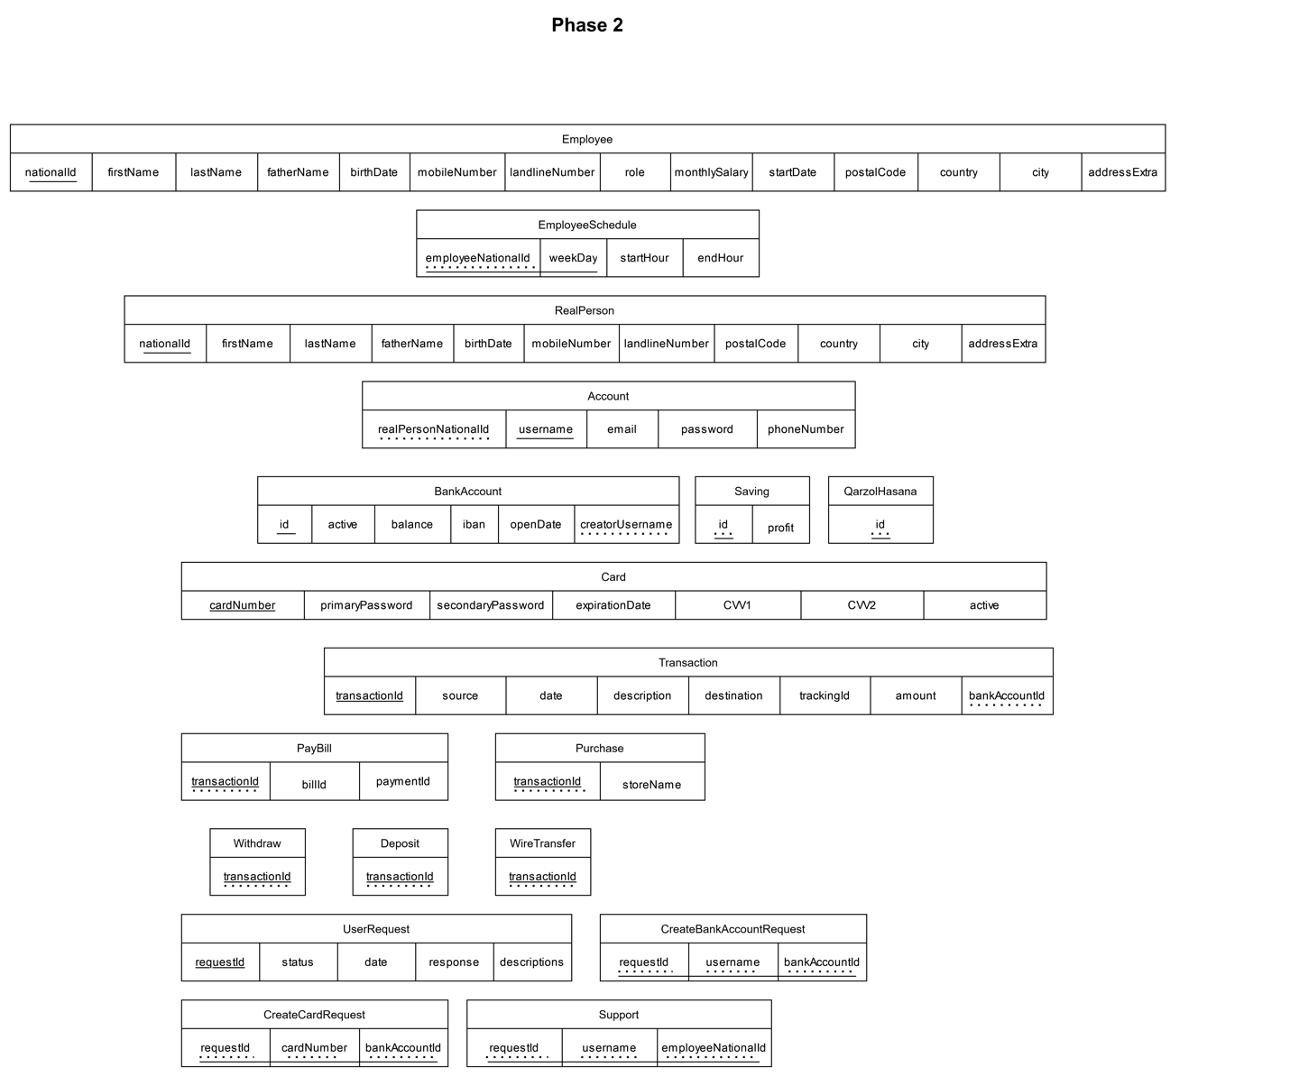

حال دامنه صفات هر یک از جدول‌ها را به دست می‌آوریم. داریم:

* Employee
  + nationalId: 10-digit number can start with 0 (string fix length: 10)
  + firstName: string (maximum length: 30)
  + lastName: string (maximum length: 30)
  + fatherName: string (maximum length: 30)
  + birthDate: date object (more than 18 years)
  + mobileNumber: 10-digit number can start with 0 (string fix length: 10)
  + landlineNumber: 10-digit number can start with 0 (string max length: 10)
  + role: text
  + monthlySalary: money object
  + startDate: date object
  + postalCode: 10-digit number can start with 0 (string fix length: 10)
  + country: string (maximum length: 50)
  + city: string (maximum length: 50)
  + addressExtra: text
* EmployeeSchedule:
  + employeeNationalId: 10-digit number can start with 0 (string fix length: 10)
  + weekDay: custom weekday enum type (defined in the database)
  + startHour: time data type
  + endHour: time data type
* RealPerson:
  + nationalId: 10-digit number can start with 0 (string fix length: 10)
  + firstName: string (maximum length: 30)
  + lastName: string (maximum length: 30)
  + fatherName: string (maximum length: 30)
  + birthDate: date object (more than 18 years)
  + mobileNumber: 10-digit number can start with 0 (string fix length: 10)
  + landlineNumber: 10-digit number can start with 0 (string max length: 10)
  + postalCode: 10-digit number can start with 0 (string fix length: 10)
  + country: string (maximum length: 50)
  + city: string (maximum length: 50)
  + addressExtra: text
* BankAccount:
  + id: serial
  + active: boolean
  + balance: money
  + iban: 24-digit number (string fix length: 24)
  + openDate: date data type
  + creatorUsername: string (maximum length: 30)
* Saving:
  + id: integer
  + profit: real (between 0 and 1)
* QarzolHasana:
  + id: integer
* PayBill:
  + transactionId: bigint
  + billId: string (maximum length: 13)
  + paymentId: string (maximum length: 13)
* Purchase:
  + transactionId: bigint
  + storeName: string (maximum length: 100)
* Withdraw:
  + transactionId: bigint
* Deposit:
  + transactionId: bigint
* WireTransfer:
  + transactionId: bigint
* Account:
  + realPersonNationId: 10-digit number can start with 0 (string fix length: 10)
  + username: string (maximum length: 30)
  + email: string (maximum length: 50)
  + password: SHA-256 hash (string fix length: 32)
  + phoneNumber: 10-digit number can start with 0 (string fix length: 10)
* Card:
  + cardNumber: string (maximum length: 19)
  + primaryPassword: SHA-256 hash (string fix length: 32)
  + secondaryPassword: SHA-256 hash (string fix length: 32)
  + expirationDate: date
  + CVV1: string (maximum length: 4)
  + CVV2: string (maximum length: 4)
  + active: boolean
  + bankAccount: integer
* Transaction:
  + transactionId: bigserial
  + source: integer
  + destination: integer
  + date: date
  + description: text
  + trackingId: bigserial
  + amount: money
* CreateCardRequest:
  + requestId: bigint
  + bankAccountId: integer
* Support:
  + requestId: bigint
  + username: string (maximum length 30)
  + employeeNationalId: 10-digit number can start with 0 (string fix length: 10)
* UserRequest:
  + requestId: bigserial
  + status: custom status enum type (defined in the database)
  + date: date
  + response: text
  + description: text
* CreateBankAccountRequest:
  + requestId: bigint
  + username: string (maximum length 30)
  + bankAccountType: custom bank account type enum (defined in the database)